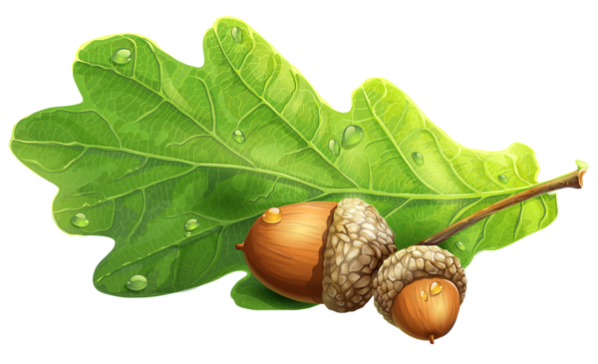

Welcome to Oak Class

A warm welcome to Oak Class from Mrs Joslin, Mrs Middleton, Mrs Enikova and Mrs Bennett.

We have loved welcoming your child into our Year 1 class this term. Our teaching and learning is tailored to the needs of your child and we strive to ensure that all lessons are engaging and practical whilst providing both challenge and support, within our nurturing environment. Let me reassure you that we will strive to keep your child safe and happy in their learning environment.

Some important information you need to know:

Morning Routines:
We are using the Oak door as our main entrance/exit. Parents are to drop off (and collect) at the gate to our learning garden. If you need to get to the preschool then you are more than welcome to walk through! We kindly ask you not to come into the classroom as it can unsettle the children. If you need to speak to an adult about your child there will always be someone at the gate to talk to!
In order to settle down calmly, activities will be set up in the classroom. There are no set tables. Children will have a choice of what they would like to do.
Eventually, we will get into a routine whereby the first job your child completes is to put away their coats, bags, lunchboxes, pop a coloured cube into the jar to indicate how they are feeling that morning and then change their reading book.

Equipment:
Your child will need a school book bag. Our cloakroom is a bit of a squash and a squeeze for all 30 children and there is limited room for rucksacks, book bags and lunch boxes etc.
If you need to store spare clothes - a small plastic bag - labelled would be easier to store on their peg rather than a rucksack as we do not have anywhere to store them. We supply all writing equipment. Medicines need to be signed in at the Office with Mrs Hayes.

Water bottles:
We encourage children to drink water during the day. Please provide a water bottle and ensure it has been filled with water at home before school. We will ensure children drink and refill their bottles throughout the day. We have a supply of cups in case your child forgets their water bottle.

Snack:
We eat a fruit snack mid-morning before playtime and this will be provided. There is no need to bring snacks in as there is always a good selection of fruit for your child to choose from. Milk however is not supplied, unless ordered and will need to be paid for.

Hair:
Please see the school uniform policy for guidance. Hair will need to be tied up for PE and ideally throughout the day to avoid the spread of ‘little friends!’ Please avoid wearing novelty headbands (Mrs Joslin is not a fan!) as they often become a distraction. Hair clips and ribbons should be of school uniform colours.

PE:
Our PE days will be on a Wednesday and Thursday this half term. On these days your child should come to school in their PE kit - please see the school uniform policy for guidance. Please label all uniform and PE kits clearly. If your child wears earrings they will need to take these out on PE days. We are not able to take earrings out so please ensure this is done before school.

We would also like your child to have a pair of labelled wellington boots in school. These will be used in our outside learning area on damper days in order for outdoor learning to continue. We are hoping to build a ‘welly rack’, but in the meanwhile, please could you pop them in a carrier bag.

Communication:
If you are unable to speak to us at the gate and would prefer to email then please contact us at oak@charminster.dorset.sch.uk. This email can be used to ask any questions you may have, to let us know if your child has had a good/bad morning, if someone different is picking them up and anything else we may need to know, or you would like us to know. It may not be answered immediately as we will be in school providing your child with the best education ever! However, if it is urgent then please phone/email the office and Mrs Hayes will pass your message on to us.

Reading:
Reading is key to your child’s progression at school. It is absolutely essential to listen to your child read on a daily basis. Last year we embarked on our Little Wandle reading journey and it has proved a big success. We have taken on board feedback from parents and so there will be a slight change this year in terms of reading and bringing books home.

There are two types of reading book that your child will bring home:
A ‘Learn to read’ practice book – Collins Big Cat. This will be at the correct phonic stage for your child. They should be able to read this fluently and independently. Children will practise reading this book, in small groups throughout the week before bringing it home on a Friday to celebrate. Please keep this book at home for the week to practise. Books will need to be returned to school on the following Friday ready for another group.
A ‘Love to read’ sharing book. This may be a book from our reading corner, the school library or from our sharing box. Your child may not be able to read this book on their own as it is not fully decodable and may not match their exact phonics level. This book is for you both to read and enjoy together in order to instil our Reading for Pleasure.
As your child continues through their Little Wandle learning journey they will move off sharing books and on to our book band scheme. Please note that we do not race through the book boxes. Listening to your child read is about quality time, not the quantity of pages they get through. It would be much more beneficial to listen to your child read a few pages and discuss what has happened rather than to gallop through the book without understanding what has happened. We will supply you with a yellow Reading Record in which you will be able to communicate with us.

Home Learning:
Home Learning will be based upon the subjects we are exploring in class and will come in the form of a grid on which children choose an activity they would like to do each week. This could be going on an autumn walk, drawing a map of where they live, interviewing a family member about their childhood, using real money to buy an item from the shops etc. We will ask for all home learning to be brought in for the half term ready to share with the class.

We are really looking forward to working together with you and your child throughout the coming year.

Mrs Joslin, Mrs Middleton, Mrs Enikova and Mrs Bennett

