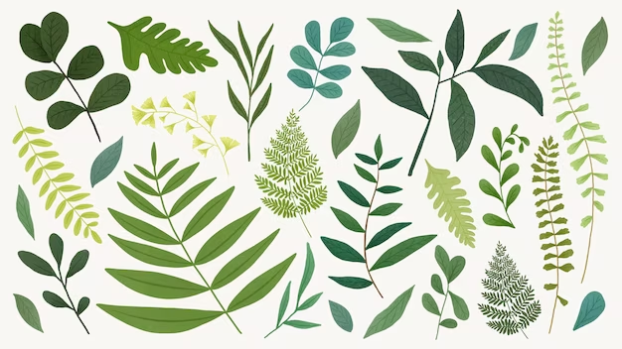
My Nature Notebook

Drawings | Name of plant | Where? | Notes
Drawings | Name of plant | Where | Notes

